PELTON PARISH
NEIGHBOURHOOD IN BLOOM COMPETITION (PPNIB)
What is the PPNIB Competition? –
The PPNIB Competition encourages community green projects, impressive floral displays and important environmental improvements in the Pelton Parish area. The aim is to create a more attractive environment in which we can all live, visit and work. The competition is open to all individuals, groups and organisations throughout the Pelton Parish area.
Only gardens viewable from a public highway or footpath are eligible,
(does not apply to allotments or schools).

Who can enter the competition?
These are the 4 different categories that you can enter-

1. School, Community Building or Business Frontage
2. Neighbourhood Area or Group Project
3. Garden or Yard
4. Allotment/kitchen garden. If you don’t have a garden, you can use plant pots, containers, window boxes or hanging baskets for your displays viewable from a public highway or footpath.
How do I enter?
All residents will have a Parish Council Newsletter delivered in February/March 2024.
Further information and an entry form is included in the newsletter.
You can also enter using the QR code below.

Everyone who participates will be helping to improve the Pelton Parish area,
and you could win a cash prize.

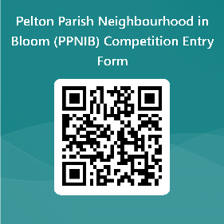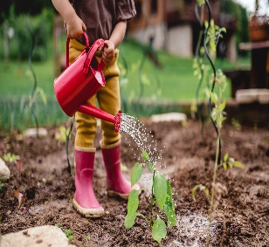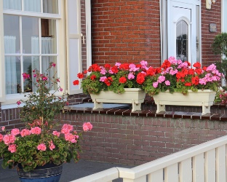
Please contact the Parish Clerk for further information on 07912688050 or clerk@peltonparishcouncil.gov.uk
All completed entries to be returned between 1.3.24 & 21.6.24. Judging will take place week commencing 1st July 2024. Winners will be informed by 31st July 2024. A presentation will be carried out in October 2024- date, time and venue tbc. Further information, rules, guidance and updates will be detailed on the Parish Council Website-

