Pelton Parish Act of Remembrance Service – to commence at 3.30pm,
12th November 2023,
War Memorial, Holy Trinity Church, Pelton.
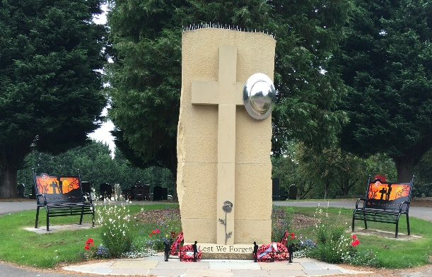
Dear Resident,

Pelton Parish Council have arranged a ceremony for residents who wish to pay their personal respects on Remembrance Sunday in Pelton Parish. Reverend John Lintern will lead the Service.

The Act of Remembrance Service will commence at 3.30pm at the War Memorial site. The Service will include an opportunity to lay a wreath and any crosses etc that you may wish to at the War Memorial. The Service will be live streamed from the Facebook Page of County Councillor Danny Wood.

If you require any further information, please contact the Clerk on
0191 3701969/07912688050 or clerk@peltonparishcouncil.gov.uk

Yours sincerely, on behalf of Pelton Parish Council.
Joanne Dickinson
Clerk & Responsible Financial Officer

