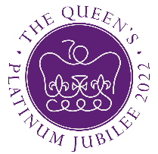



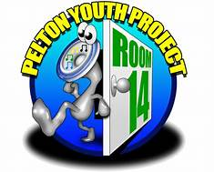




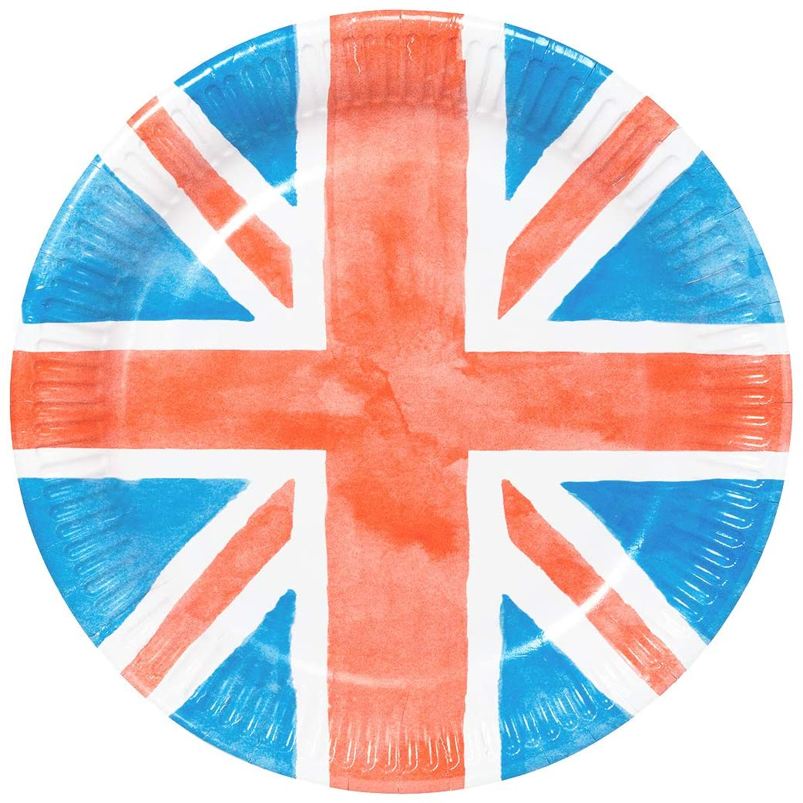
Rouse School of Dance Performances
£1 a ticket
(Tickets on sale Monday 16th May)
To purchase tickets please pop into Pelton Community Centre Reception, cash only. Call us for more info 0191 3700726. We will have a photographer present on the day. Kindly funded by The National Lottery’s Community Fund.
Craft Stations
Family
Fun
Day
‘Please come in your Red, White and Blue clothes’
Ticket only event, Limited tickets available, under 1’s go free. Sales limited to 5 tickets per person.
Drop in between 1-4pm
Sunday 5th June 2022
Refreshments
And much more!
Graffiti Artist
Cakes
Culture for Kids
Magician
Tombola
Raffle
Free Hot Dogs
Candy Kids
Stalls

