Write to:- Clerk, Pelton Parish Council, Council Office,
Pelton Community Centre, Front Street, Pelton, Chester-le-Street, Co. Durham. DH2 1DE

Email - clerk@peltonparishcouncil.gov.uk Tel: - 0191 370 1969

Your Reference – CLS16249

3rd March 2021

Eve Wyke

WHP Telecoms

Via email- e.wyke@whptelecoms.com

Dear Ms Wyke

Subject: Proposed 5G Telecommunications Installation for H3GUK

Further to your letter dated 17th February 2021 informing stakeholders of the proposed installation prior to the submission of a formal planning application for the following-

- Proposed 18.0m Phase 8 monopole c/w wraparound cabinet at base and associated ancillary works located at Front Street, Pelton, DH2 2SP. (Please note the correct address is Front Street, Newfield, DH2 2SP.)

Firstly, thank you for providing the information to Pelton Parish Council for a review prior to submitting a planning application. Pelton Parish Council reviewed and discussed the information you provided regarding the proposed location during a meeting held on 24th February 2021. The Parish Council object to the proposed location of the mast and cabinets for the following reasons.

1. Proposed location is unsuitable and non-compatible to the guidelines for new mast and cabinet locations detailed as follows in the National Planning Policy Framework, The County Durham Plan, The Code of Best Practice on Mobile Network Development in England and The Mobile Operators Ten Commitments on Siting and Design Principles.

a. The National Planning Policy Framework
Number 113- The number of radio and electronic communications masts, and the sites for such installations, should be kept to a minimum consistent with the needs of consumers, the efficient operation of the network and providing reasonable capacity for future expansion. Use of existing masts, buildings and other structures for new electronic communications capability (including wireless) should be encouraged. Where new sites are required (such as for new 5G networks, or for connected transport and smart city applications), equipment should be sympathetically designed and camouflaged where appropriate.

b. The County Durham Plan
Section 5.272 In accordance with the National Planning Policy Framework (NPPF), all new infrastructure installations should, where possible, minimise the number of masts and new sites required and be sympathetically designed and camouflaged where appropriate. In this context the phrase ‘visual clutter’ is used to describe the visual impact created by bringing together a number of potentially unrelated structures in one place resulting in an overwhelming and unsightly cluster. Therefore, the cumulative impact of additional infrastructure being added to an existing site will need to be taken into account as part of the application process.

c. The Code of Best Practice on Mobile Network Development in England.

Section 2.4- Where new sites are required equipment should be sympathetically designed and camouflaged where appropriate.

d. The Ten Commitments of Mobile Operators on Siting and Design Principles

Commitment 10, Design: operators will ensure, especially in the case of new sites, that equipment is sympathetically designed, in line with the principles set out in the National Planning Policy Framework.

Summary of point 1

The proposed location does not adhere to the guidelines detailed in points a-d as it is next to a highway, on a footpath and does not have any camouflage taken into consideration. The additional base units will result in an overwhelming and unsightly cluster of street furniture.

2. Proposed location will reduce the available footpath space through the cluster of street furniture consisting of three new base cabinets.

a. The County Durham Plan Policy on Signage, Adverts, Street Furniture and Public Art detailed on p.152

Proposals should ensure: Street furniture, public art, adverts and signage are appropriate and sympathetic to all users and the local setting in terms of scale, design, lighting and materials

Summary of Point 2

Parents taking their children to school along with pushchair and wheelchair users regularly walk this footpath. This additional street furniture cluster is detrimental to footpath users.

3. Proposed height of the mast will overlook residential properties and may be a distraction for road users driving through the village.

Summary of Point 3

These factors are Material Planning Considerations and should be considered if a planning application is submitted.

4. Proposed location is within 50 metres of a Nursery and Primary School playground and premises.

The following government guidelines clearly state the risk is low to health but the proposed location within 50 metres of the school, the playground and their outdoor play and learning area is an unacceptable and unnecessary risk.

a. Radiowaves and health

It is possible that there may be a small increase in overall exposure to radio waves when 5G is added to an existing network or in a new area. However, the overall exposure is expected to remain low relative to guidelines and, as such, there should be no consequences for public health.

b. Mobile phone base stations radiowaves and health

Monitoring of exposures
The radio-wave exposure level produced by base stations depends on their output powers, the directional characteristics of their transmitting antennas and where people can be exposed in relation to the antennas. In general, being closer to an antenna results in higher exposures, but the most powerful antennas tend to be mounted high up on masts or buildings, and they are designed to direct most of their power towards the horizon, so exposure levels beneath antennas are small. Antennas located nearer to street level and inside buildings are designed to communicate over short distances and transmit with lower power levels than antennas mounted at height. People can access directly in front of these types of antennas, but the exposure levels are low due to the low output powers.

The maximum output power from each base station is set by operators to balance call/data traffic across the different sites that make up the network. The actual output power at any given time depends on the amount of calls and data being handled and use of excessive power at any given site reduces the capacity of the network for other users. So, optimising transmitted powers to be the minimum needed to carry out communications effectively is an important feature of efficient network design. It also tends to keep public exposures low.

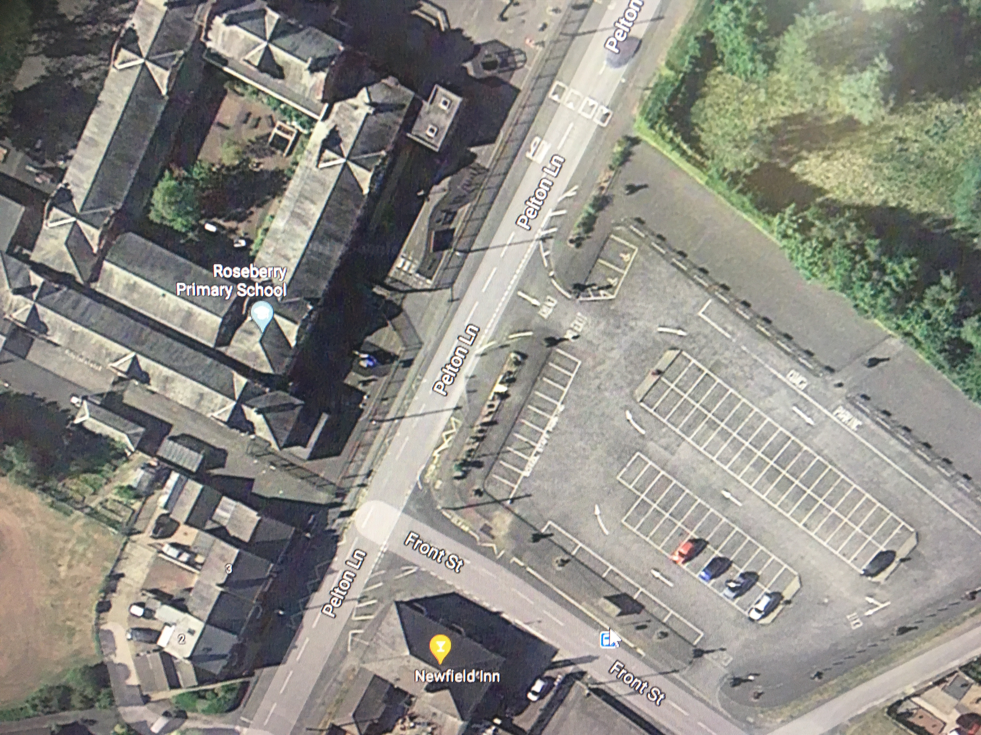
Proposed location of mast and cabinets at bus stop on Front Street and the close proximity to the school buildings and outdoor play areas.

Summary of Point 4

The school is a nursery and primary school admitting children from the age of 2. The children could spend up to 10 years at the school and as government guidelines state the risk is low of exposure to radiowaves, the closer the mast is to the school the risk increases. As the children may be at the school for up to 10 years that is an unacceptable amount of risk. In addition, the construction and maintenance works will be near to the school where children and parents walk past to go to school leading to a potential safety risk to children and parents.

Pelton Parish Council request that you take all these matters into consideration when reviewing the proposed location of the mast and base cabinets. Please also provide us with the information collated on any previous locations considered for the mast and cabinets.

A consultation meeting with all the stakeholders would be welcomed by the Parish Council and local residents’ in order to discuss alternative and more suitable locations for the equipment.

I look forward to hearing from you.

Yours sincerely, on behalf of the Council

Joanne Dickinson

Clerk and Responsible Financial Officer

https://www.gov.uk/government/publications/5g-technologies-radio-waves-and-health/5g-technologies-radio-waves-and-health
https://www.gov.uk/government/publications/mobile-phone-base-stations-radio-waves-and-health/mobile-phone-base-stations-radio-waves-and-health

