
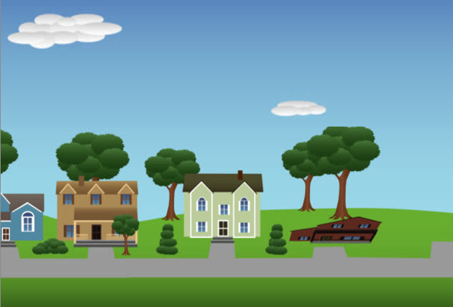
TOPIC OF MEETING
TO COME ALONG AND SPEAK TO THE POLICE, FIRE, STREET WARDENS, COUNTY COUNCILLORS AND LANDLORDS ABOUT GOOD AND BAD THINGS ABOUT LIVING IN GRANGE VILLA. THE IDEAL OUTCOME WILL BE FOR EVERYONE TO COME UP WITH SOLUTIONS TO PROBLEMS AS A COMMUNITY
- - - - - - - - - - - - - - - - - - - - - - - - - - - - - - - - - - - - - - - - - - - - - - - - - - -
We invite you to a Resident Meeting
2pm at Grange Villa Community Centre
Saturday 8th January

